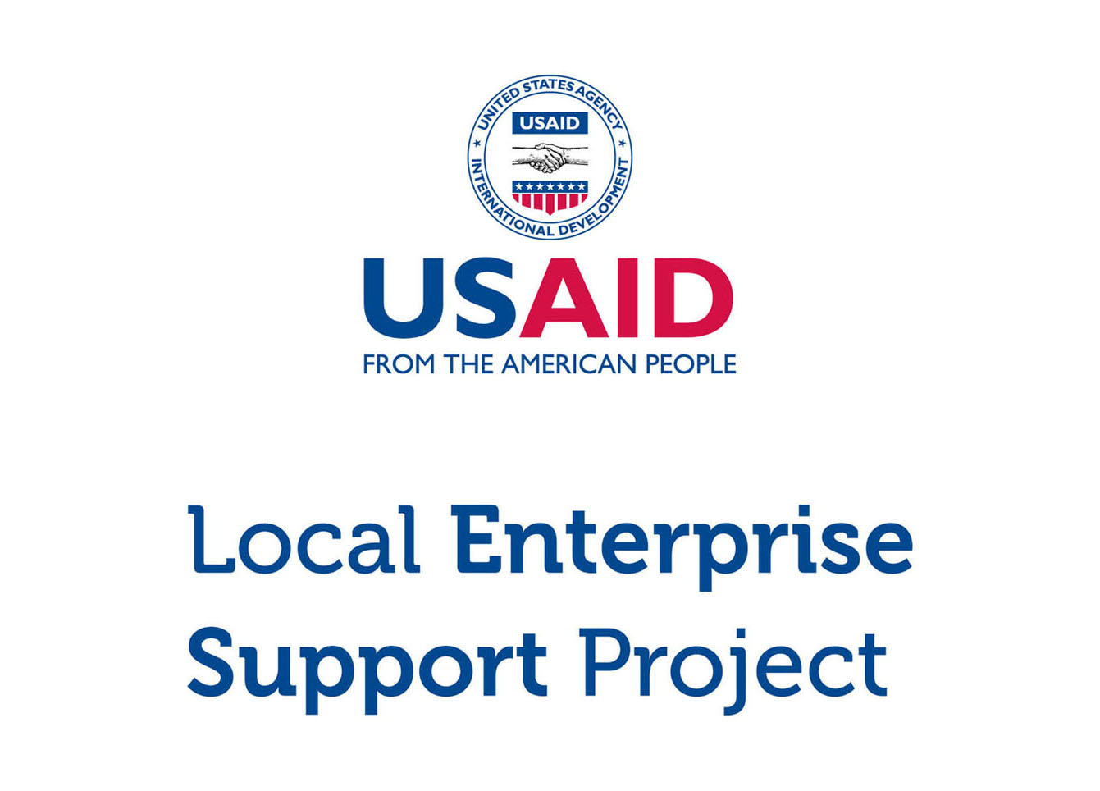

**Micro and Small Enterprise (MSE) Survey**

Results for Tafilah Governorate

Tuesday, March 15, 2016

**DISCLAIMER**

The USAID Jordan Local Enterprise Support (LENS) Project is funded by the United States Agency for International Development (USAID) and implemented by FHI 360. This report is made possible by the generous support of the American people through the United States Agency for International Development (USAID). The contents are the responsibility of FHI 360 and do not necessarily reflect the views of USAID or the United States Government.

**ACKNOWLEDGEMENTS**

This report was written by Bryanna Millis and Rafael Pilliard-Hellwig, with contributions from Faisal Awartani, Muin Khoury, Edmund Morris, and Jonathan Peters. The report was translated by Dania Mousa and Shadi Al Rawashdeh.

# Highlights

|  |  |  |
| --- | --- | --- |
| 2,120  MSEs |  | MSES ARE THE MAJORITY > There are an estimated 2,120 micro and small enterprises in Tafilah. Roughly three in four MSEs are single-person businesses, and two thirds operate in retail and trade. |
|  |  |  |
| 10 %  WOMEN |  | MSES ARE MALE-DOMINATED > Only 9.8% of Tafilah’s MSEs are woman-owned. Women who have MSEs are more likely than men to earn less, to operate out of home locations, and to work out of necessity. |
|  |  |  |
| 6/10  ARE REGISTERED |  | MSES EXIST ON PAPER > Despite the fact that most MSEs do not pay tax and few have employees, 59.5% are nonetheless registered with the Ministry of Industry and Trade. |
|  |  |  |
| 5 YEARS  IN EXISTENCE |  | MSES ARE NACENT > The typical MSE has been in business for five years. 91.8% of businesses in Tafilah believe they will continue to operate for at least 3 years. |
|  |  |  |
| 300 JD  PROFIT |  | MSES STRUGGLE TO GET BY > MSEs that make profit report a median bottom line of 300 JD per month (usually excluding the MSE owner’s own salary). 60.8% of MSEs are losing money or struggling to live comfortably. |
|  |  |  |
| 9% USE  COMPUTERS |  | MSES ARE DIGITALLY ABSENT > Only 8.7% of businesses use a computer in the course of their work. 14.6% use social media either for work or personal purposes. |
|  |  |  |
| <11%  PENETRATION |  | MSES LACK COLLECTIVE POWER > Memberships in associations are weak. With the exception of the chambers, the penetration rate for trade associations, business groups, and cooperatives is below 11%. |
|  |  |  |

Table of Contents

Introduction 5

General Demographics 6

Contracts 18

Workforce 19

Firm Performance 22

Access to Finance 25

Systems, Processes and Networks 28

Policy and Regulations 32

Data was compiled using data file **new_lens_usa_fix_pswt.sav**” (MD5 hash: 3958a9180d)

# Introduction

## About USAID LENS

The USAID Jordan Local Enterprise Support Project (LENS) is a five-year project to encourage the long-term economic growth and development potential of underserved Jordanian communities. USAID LENS combines local economic development with private sector development initiatives to help create jobs and sustainable growth that is inclusive of women and youth.

LENS’ systemic approach to local economic development is meant to catalyze inclusive local and regional economic networks in a business-enabling environment, while developing the competitiveness, sustainability and growth of micro and small enterprises.

## About the Survey

Although Jordan’s economy is dominated by micro and small enterprises (MSEs).[1] relatively little is known about them. To overcome this informational gap, USAID LENS conducted a survey of MSEs in 2014-2015 to better understand Jordanian enterprises and to assess the major barriers and opportunities for growth. The study covers general demographics, workforce trends, firm performance, access to finance, processes and networks, and the impact of the Syrian refugee crisis.

The survey consists of 86 questions in a double sampling design with stratification. The data gathers representative information for all MSEs operating in the governorates of Amman, Zarqa, Irbid, Karak, Tafilah, and Aqaba.[2] Although the study is not intended to be national in scope, the target population of the six areas collectively capture 60% of the kingdom’s population.

As a complex survey, the research design was undertaken using probability sampling in two phases. In the first phase, 977 geographic clusters were randomly selected from districts in each area. From these clusters, 97,347 households were contacted through door-to-door interviews, of which 10,197 reported owning a business. A sub-sample of 6,385 MSEs was then drawn, stratified by sector governorate. 4,721 of these MSEs were then successfully surveyed (891 in Tafilah)

This report focuses exclusively on results for the governorate of Tafilah. Findings are taken from USAID LENS’ MSE survey, and can reliably be generalized to all MSEs within this geographic boundary.[3]

# General Demographics

## Firm Characteristics

Based on the survey research, there are an estimated 2,120 MSEs in Tafilah governorate.[4] An overwhelming majority of these are owned by men (90.2%).

The proportion of man-owned to woman-owned businesses is generally consistent with government figures. According to the Department of Statistics (DOS), women account for only 13.0% of the labor force nation-wide. According to the survey, just under one out of 10 businesses in Tafilah either employs women or is managed by one.

|  |  |  |  |  |  |
| --- | --- | --- | --- | --- | --- |
| **Demographics (Tafilah)** |  | **Sample** |  | **Population Estimate**[5] | |
|  |  | *n* = 891 |  | *N* = 2,120 | % of group |
| **By Select Sector[6]** |  |  |  |  |  |
| Food Processing |  | 403 |  | 883 | 41.7% |
| Tourism |  | 74 |  | 186 | 8.8% |
| Transport |  | 55 |  | 114 | 5.4% |
| ICT |  | 20 |  | 47 | 2.2% |
| Other |  | 339 |  | 889 | 42.0% |
| **By Sex of the Owner** |  |  |  |  |  |
| Men |  | 794 |  | 1913 | 90.2% |
| Women |  | 97 |  | 207 | 9.8% |

Food Processing accounts for the largest of the four sectors above, representing 41.7% of all MSEs in Tafilah. Tourism follows with 8.8%, Transport with 5.4%, and ICT with 2.2%. MSEs outside of these target sectors account for the remaining 42.0%.

Tafilah has a number of subsectors that are proportionally more important. MSEs in Tafilah are more likely than MSEs in other surveyed governorates to be in retail sale of food, beverages and tobacco, manufacture of dairy products and food products, and animal production. Surprisingly, it is also much more likely to find MSEs in amusement and recreation activities in Tafilah than the other areas surveyed.[7]

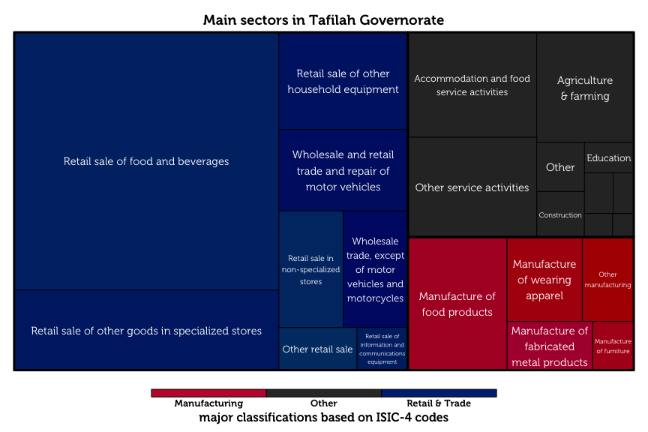The tree map diagram above shows the relative sizes of each business category, as classified by ISIC-4 codes. Retail and trade dominates as the largest sector (63.5%), with a higher proportion of MSEs in the Retail sale of food, beverages and tobacco in specialized stores than in any other governorate. The second largest is manufacturing, at 14.4%.

## Respondent Characteristics

The typical MSE owner in Tafilah is a married, 42-year old man with secondary school as his highest level of education. 57.6% of these owners have families of moderate size (4 – 7 members). Male business owners are typically the primary earners of their household, in sharp contrast to women MSE-owners, who are rarely the breadwinners for their families.

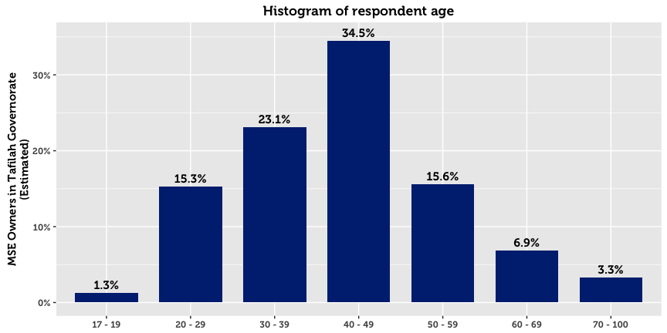

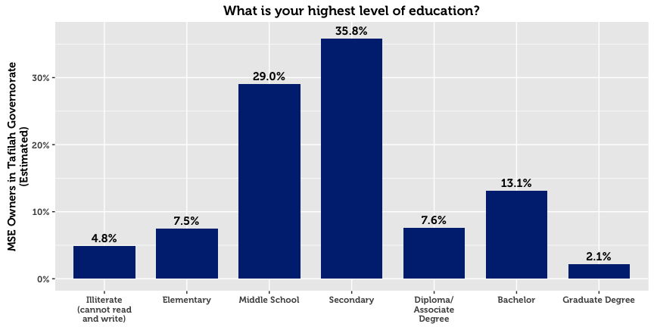

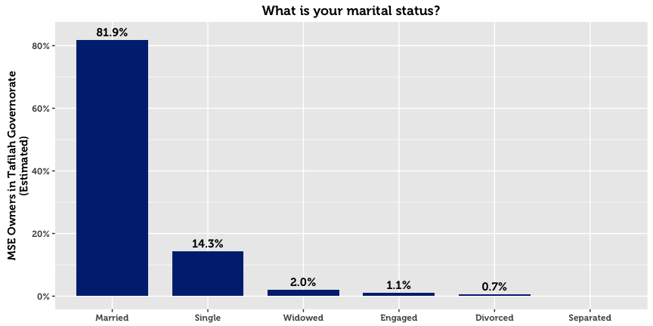

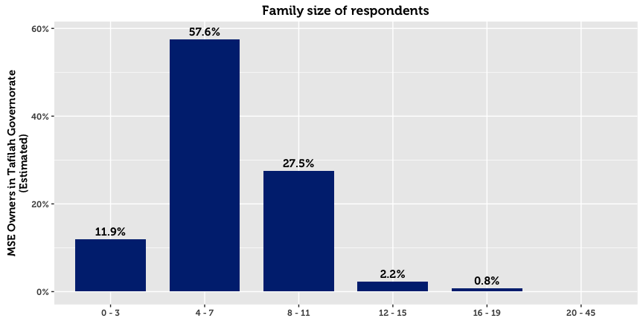

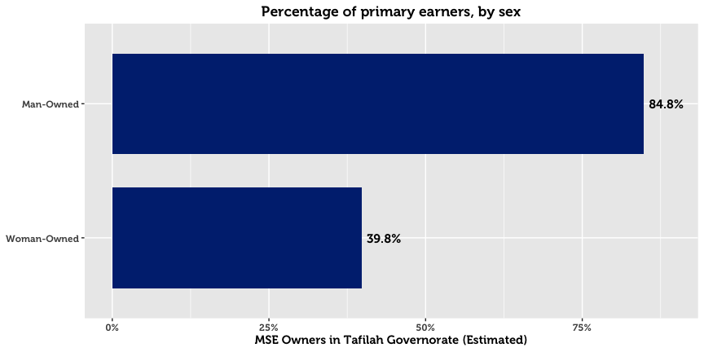

## Establishment, Registration & Business Continuity

The survey reveals that half of the MSEs in Tafilah in existence today were established after 2010. In fact, governorates in the south have, on average, registered more recently than northern governorates. In Tafilah, the typical company is registered since 2010, compared to a median of 2008 for the governorates of the north.

A higher number of businesses are registered with the Ministry of Industry and Trade (MoIT) than anticipated. 59.5% of all MSEs in Tafilah are registered with the Ministry, a figure that is dramatically higher for man-owned businesses (64.3% for men compared to 14.8% for women). Registered businesses tend to be older than unregistered businesses by an average of two years.

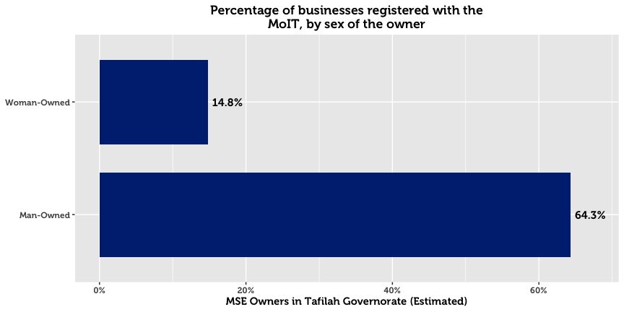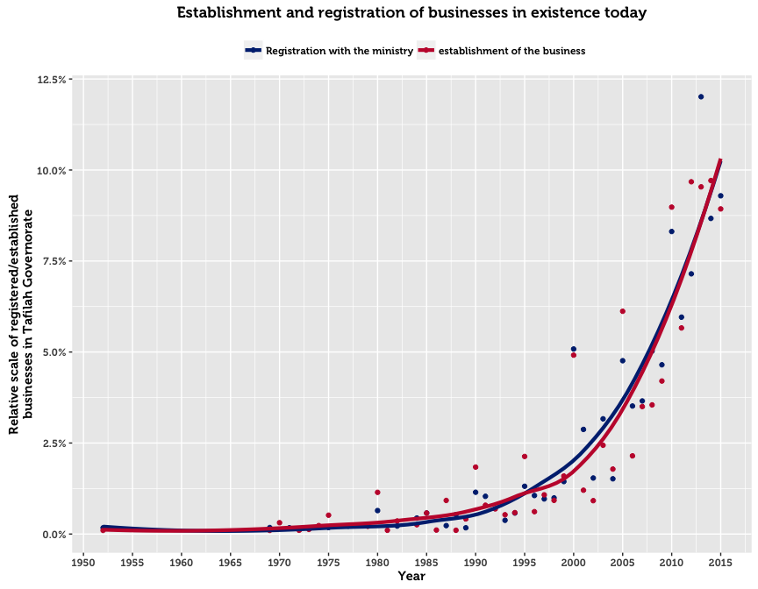

The above chart plots the frequency of business establishments and registrations by year. Almost all registered businesses were established and registered in the same year. The upward trend in registrations over time is most likely explained by three factors: (1) growth in the population of Jordan, (2) initiatives by the government to increase awareness and simplify the registration process, and (3) the fact that former establishments are not captured by the survey. The third reason implies that businesses that existed in the past but no longer operate become excluded from the sample. Such companies may have gone out of business for financial reasons, or ceased to exist due to the passing of the owner.

For those who chose to register, two main reasons emerge. The first is that MSE owners fear fines or harassment by police and authorities (the primary reason for 40.7%). The second reason is that registration is legally compulsory for their type of business (cited by 39.4%). Government support, availability of insurance or official protection, and access to finance were not considered to be important primary motivations for business registration.

On the flip side, the dominant explanation given by half of unregistered MSEs in Tafilah is that owners do not see any benefits from officially registering their business (51.9%). Other reasons such as cost, lack of understanding, and administrative complexity are far less important.

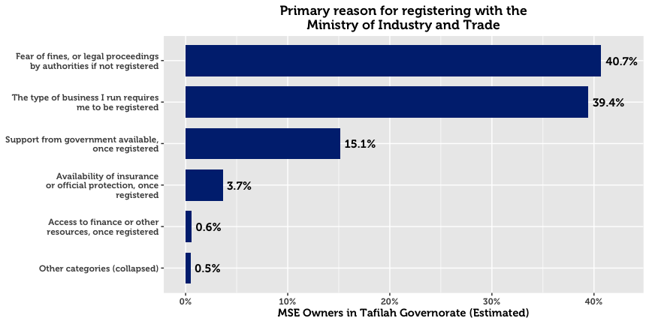 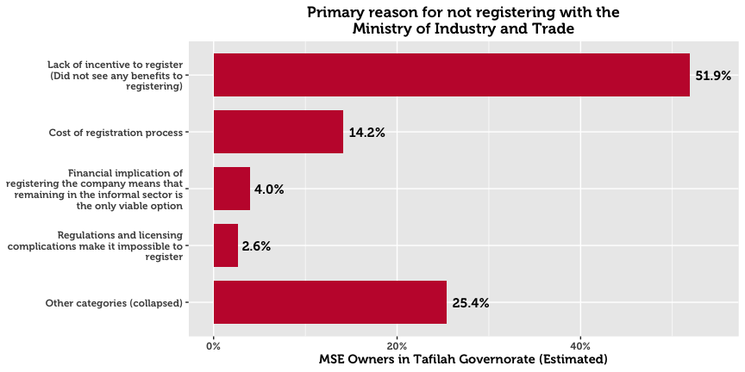

## Seasonal Business

An estimated 86.0% of MSEs operate all year round. Woman-owned businesses, home-based businesses, and non-registered enterprises are more likely to be seasonal.

## Working Hours

71.2% of business owners work over the recommended 49 hours a week, a higher proportion than in any other governorate. Registered businesses are also more likely to put in long hours.

## Location of Conducting Business

In Tafilah, the majority of business is conducted from fixed location outside of the home (81.1%). This primacy of fixed locations is consistent across sector and sex of the business owner. However, it is much less pronounced for women-owned businesses, as men are 2.9 times as likely to operate out of a fixed location outside of the home.

In stark comparison, 17.9% of MSEs are home-based[8]. Gender differences on this dimension are high: 70.0% of woman-owned businesses operate from their home, compared to 12.3% for man-owned businesses. Certain industries are much more likely to be home based compared to other industries. These include the manufacture of dairy products, animal production, manufacture of dairy products, retail sale in non-specialized stores, retail sale in non-specialized stores, manufacture of wearing apparel.

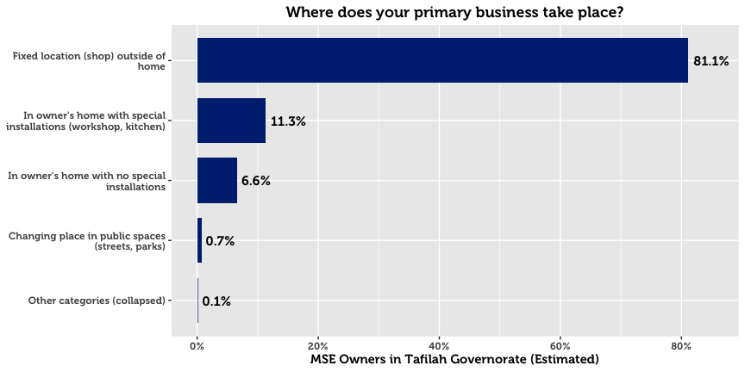

## Business Motivation

The main motivation for starting an MSE in Tafilah is to generate income for the individual’s family, cited by 43.9% of MSEs. Starting a business out of financial necessity is a much stronger motive in Tafilah compared to any other governorate, and in particular more so than the northern governorates surveyed, where only 16.7% cited this as the primary reason for going into business. The second reason is simply because individuals wish to own their own enterprise (36.7%), followed by a desire to work in the industry (8.5%).

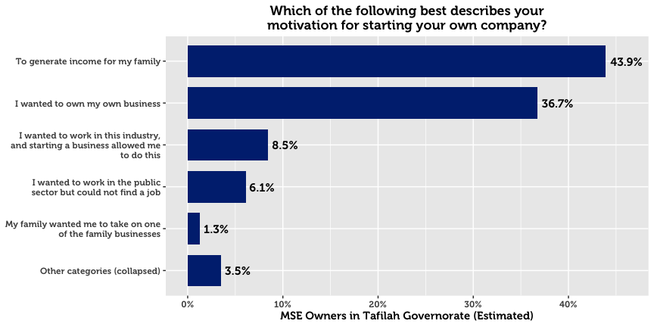

Conducting Other Business

35.4% of MSE owners in Tafilah have more than one business or income-generating project—a higher rate than in any other governorate surveyed. In fact, of the governorates in the study, the southern ones are three times as likely as those of the north to have another business. Men are also more likely to have a secondary business (by a factor of 1.2).

## Legal Ownership of Business

82.4% of businesses in Tafilah are self-owned. 4.5% are owned by a male family member, and 3.4% by a male non-family member.

## Form of Incorporation

The majority of MSE owners who are formally registered exist as sole proprietorships (95.8%). Others are typically either General Partnerships (1.5%) or Limited Liability Companies (0.9%).

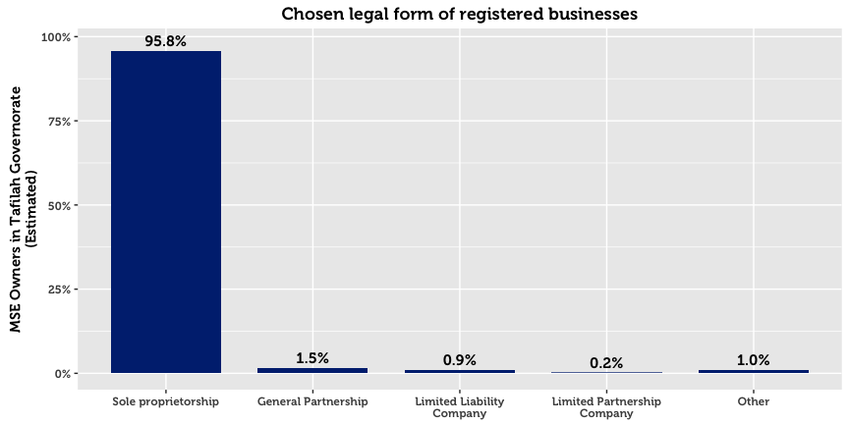

## Licensing

MSEs are by and large licensed with their municipalities, though a lower proportion are licensed in Tafilah compared to most other governorates. There exists a subset that claim to be registered but not licensed (4.7%), and a subset that are licensed but unregistered (3.9%). This may point to either a) misunderstanding of the question on behalf of the respondent, b) an expired license from the municipality, or c) an informal or illicit acquisition of a license from the municipality. As one might expect, home-based businesses have far higher chances of being unlicensed.

The two primary reasons cited my MSE owners for not being licensed are that and that they see no benefits to doing so (28.7%), and that it is not required for their business (26.8%) Compared to other governorates, a relatively high proportion cite the latter as the main reason. A quarter of respondents cited “other reasons,” perhaps due to reluctance to answer truthfully to a sensitive question.

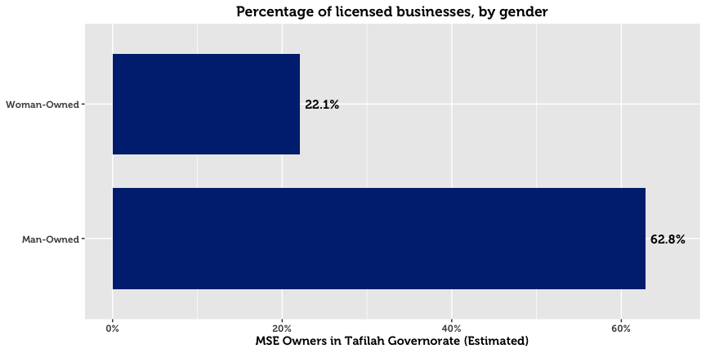

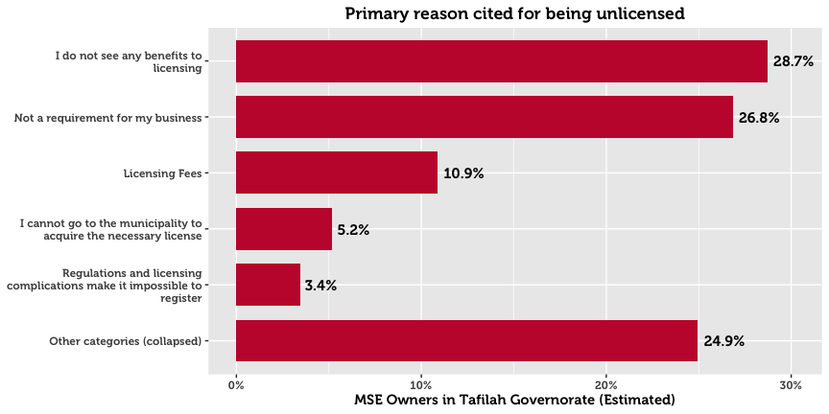

# Contracts

A large majority of surveyed enterprises never sign contracts: 89.4% of all MSEs. Only 7.1% report signing contracts either always or often. In the event of a dispute, 56.6% of MSE owners opt to take legal proceedings, suggestive of a comparatively greater regional trust for the court system. 9.2% report that they will resort to doing nothing. 11.7% will resort to an informal meeting, 8.1% would use a local tribunal, and 6.9% family intervention.

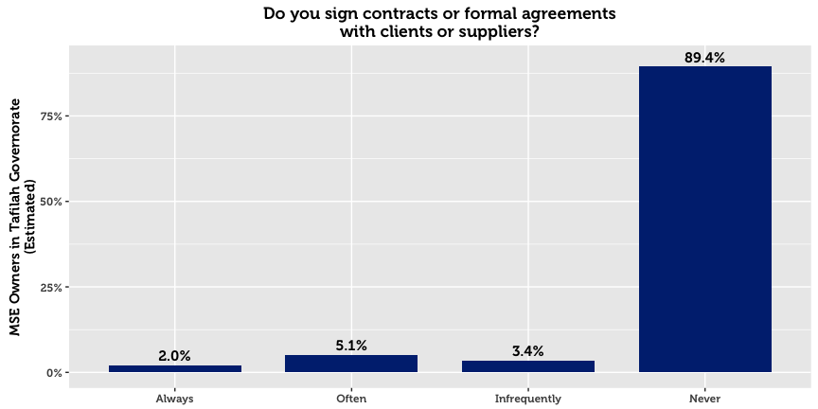

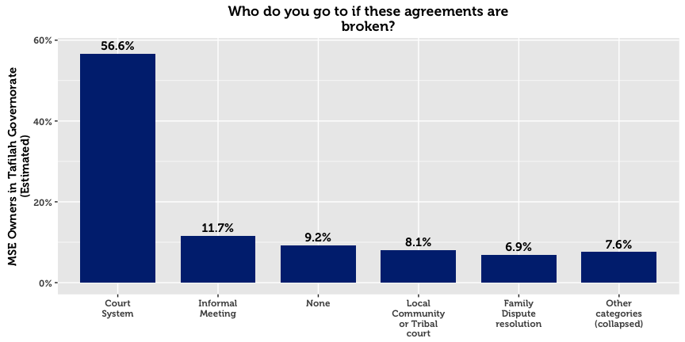

# Workforce

Less than a third of Tafilah’s MSEs hire employees—30.5%. 23.9% of MSE’s employ full-time Jordanian workers, a relatively low proportion compared to other governorates. Of all MSEs in Tafilah, 10.9% employ just one full-time worker, 7.1% employ two workers, and 6.0% employ three or more. Part-time labor is relatively uncommon, as only 9.7% of Tafilah’s MSEs hire Jordanians on a part-time basis. Employment of women is also rare, as only 3.1% of MSEs hire full-time Jordanian women (compared to 21.9% who hire men), and only 11.9% of MSEs are either woman-owned or hire other women. No strong differences emerge among subsectors in Tafilah with respect to the hiring of women.

52.3% of MSEs with employees in Tafilah did not hire any new employees in the last year. 15.6% hired exactly one employee. 8.2% of these enterprises report employing workers below the age of 18.

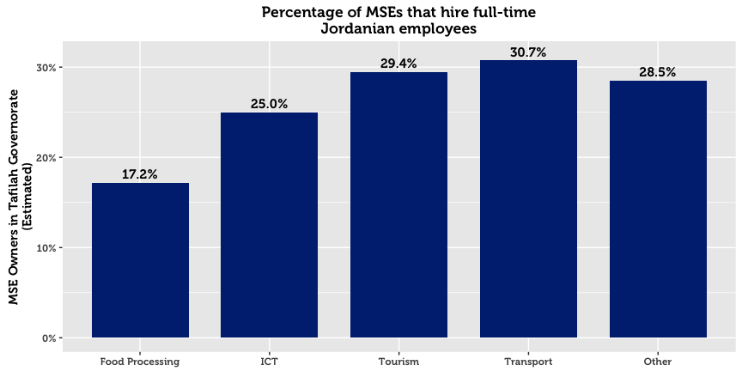

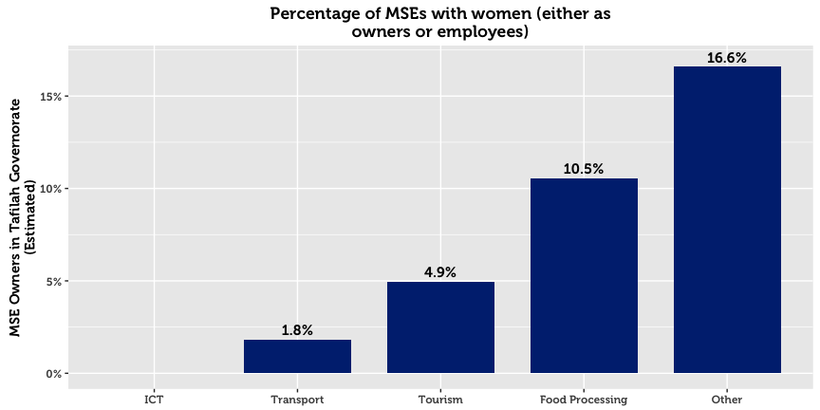

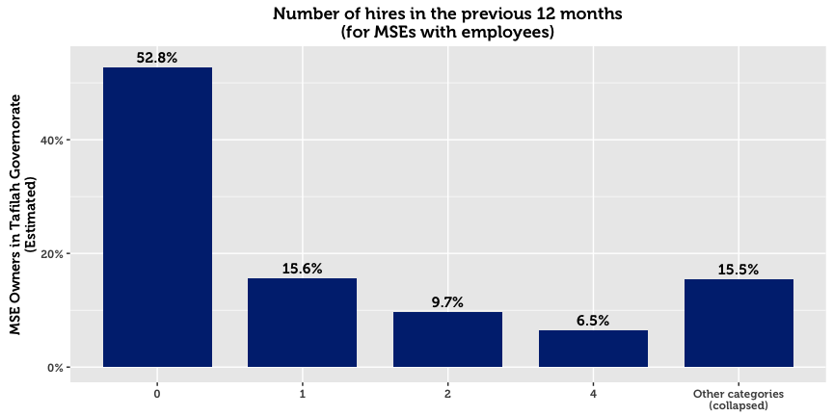

One in five enterprises hire between 1-3 workers. Of those that hire workers, 72.9% say that none left their business during the previous 12 months. Of those that experience talent loss, the major attributions are loss to public service employment, personal reasons, loss to competitors, and employees leaving to start their own business.

|  |  |  |
| --- | --- | --- |
| **Primary Reason for Employee Loss (Tafilah)** |  | **All** |
|  |  | *N* = 175 |
| Employee took government or public service employment |  | 33.2% |
| Personal reasons |  | 16.8% |
| Employee is hired by a competitor at a better rate |  | 9.2% |
| Employee left to start their own business |  | 8.2% |
| Other reasons (remaining categories collapsed together) |  | 32.5% |

## Employee Training

Most MSEs with employees – 63.8% – do not offer their workers in-house training. Those that do typically offered technical training or informal mentorship. External trainings for employees are less common at 8.1%.

|  |  |  |  |  |
| --- | --- | --- | --- | --- |
| **MSEs that Offer Employee Training* (Tafilah)** |  | **In-House** |  | **External** |
|  |  | 36.2%  *N* = 233 |  | 8.1%  *N* = 52 |
| Technical training/advice in your industry |  | 28.8% |  | 8.1% |
| Informal advice/mentorship |  | 27.3% |  | 5.8% |
| Marketing assistance/market information |  | 19.8% |  | 5.0% |
| Business Management training |  | 15.5% |  | 4.1% |
| Human resources/soft skills training |  | 7.5% |  | 3.1% |
| Recordkeeping |  | 7.2% |  | 3.1% |
| Other |  | 9.9% |  | 1.5% |
| *\* Domain of analysis comprises only companies with employees (646 total)* | | | | |

## External Assistance

It is estimated that only 1.5% of MSEs in Tafilah receive technical assistance.[9] A very small proportion receive assistance[10] from a donor-funded program (1.1%), a government (0.4%), or business service provider (0.4%).

# Firm Performance

60.8% of MSE owners report that they are either losing money or struggling to live comfortably. Only 37.6% of surveyed enterprises maintain that their business allows them to live comfortably, and 1.7% claim that their company allows them to live well above their living costs.

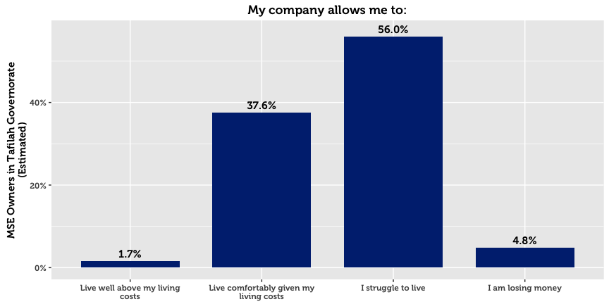

## Barriers to Economic Growth for MSEs

Although 83.1% of MSEs in Tafilah wish to expand their business, many of them face challenges in doing so. MSE owners were asked to state whether they agreed or disagreed that the following items represent barriers to the development their firms:

|  |  |  |  |  |  |
| --- | --- | --- | --- | --- | --- |
| **Barriers to Success (Tafilah)** |  | **All** |  | **By Sex** | |
|  |  | *N* = 2,120 |  | Men | Women |
| Low Demand |  | 62.1% |  | 62.4% | 59.6% |
| Low Purchasing Power |  | 59.6% |  | 60.1% | 54.8% |
| Price of inputs increased |  | 54.2% |  | 54.8% | 48.0% |
| Lack of financial support |  | 48.0% |  | 48.2% | 45.2% |
| Lack of family support |  | 37.9% |  | 38.4% | 33.0% |
| Lack of appropriate sellers |  | 35.4% |  | 35.2% | 37.1% |
| Cannot compete with quality of products |  | 29.6% |  | 30.2% | 24.1% |
| Uncompetitive products |  | 26.9% |  | 27.1% | 25.6% |
| Lack of human resource options |  | 26.0% |  | 27.1% | 16.1% |
| Unreliable transportation network |  | 25.1% |  | 24.8% | 27.8% |
| Weak technical support or skills in this area |  | 24.4% |  | 25.6% | 13.2% |
| Lack of proper marketing skills |  | 22.7% |  | 22.8% | 21.5% |
| Lack of market information |  | 22.2% |  | 22.7% | 18.0% |
| Lack of management skills |  | 19.2% |  | 19.8% | 13.4% |

The majority of firms believe that the major barriers are macroeconomic in nature. Low demand and low purchasing power top the list of barriers to success. Despite the fact that most MSEs lack many formal processes and mechanisms such as a bank account or trainings, most do not perceive this a major gap or barrier. Comparatively, more or Tafilah’s SME owners perceive lack of financial support to be a barrier to success (48.0%) than in any other governorate. More MSEs in Tafilah indicated that a lack of appropriate suppliers was a barrier to development compared to the governorates of the north (35.4% in Tafilah, compared to a combined average of 19.6% for the governorates of the north).

## 

## Financial Performance

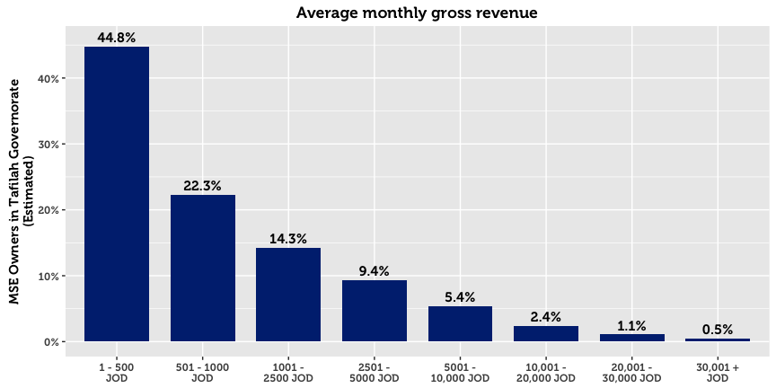

44.8% of MSEs in Tafilah report a monthly turnover of 500 JOD or less. However, 10.4% either refuse to disclose the exact amount, or do not know the amount. On average, non-registered enterprises, home-based businesses, and single-person MSEs reported significantly lower gross revenue.

Profit is a more sensitive issue: Although 67.2% report finishing the previous month in the black, 0.8% refuse to disclose the exact amount, and 5.9% do not know. Nevertheless, of those who make profit and are willing to share this information, the median profit is 300 JOD. The median amount of savings per month in Tafilah is 200 JOD.

|  |  |  |
| --- | --- | --- |
| 12.5%  Of MSEs in Tafilah make  monthly savings |  | 81.3%  Of MSEs in Tafilah make no  monthly savings |

# Access to Finance

Over half of micro and small enterprises in Tafilah generate enough money to sustain themselves without outside financing. Although many MSE owners struggle to live comfortably, as many as 17.4% of those who do not take a loan say that they do not need one. Accordingly, financial institutions do not play a major role in the economic development of most MSEs, evidenced by the fact that only 16.4% of MSEs have applied for credit. Being in the Middle East, religious reasons have a part to play in this phenomenon. Although the rise of Islamic Banking products has expanded the market, no less than 23.6% of MSE owners cite religious prohibition as the main reason for not taking a loan (more important than any other of the options). The overall availability of credit may be another supporting factor. However, the most likely explanation is that MSE owners do not interact much with providers of credit, or even know about money markets. This is likely in view of the fact that only 12.8% of MSEs have bank accounts, that most loan applications get approved (75.3% reported approval), and that only 10.3% believe that they only have one source of credit to their disposition.

Approved loans are typically used for business purposes, primarily to buy more resources, add new products or business activities to the current business, or to improve or upgrade products already being sold. Only in limited cases is financing used to expand or purchase property (6.4%) or to pay off company or personal debts (6.0%).

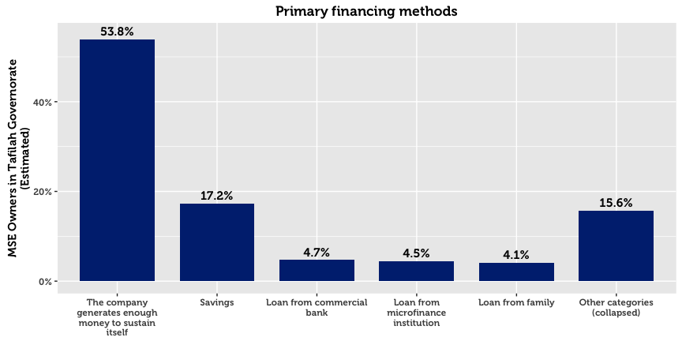

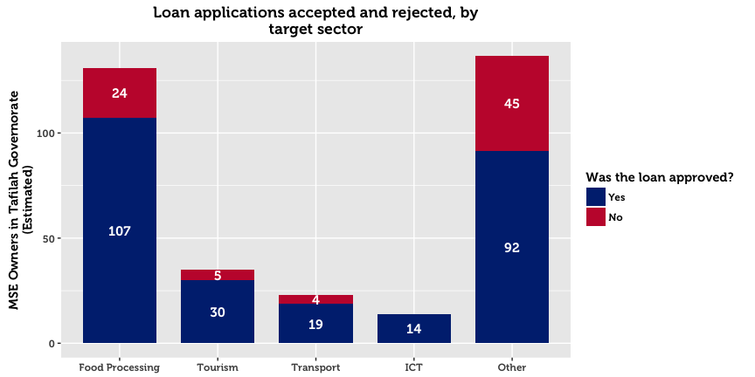

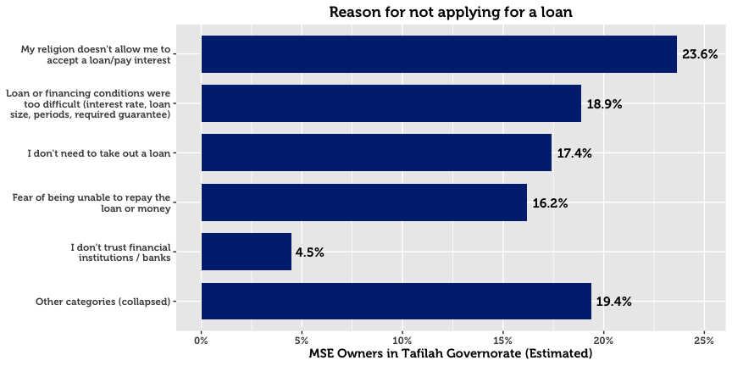

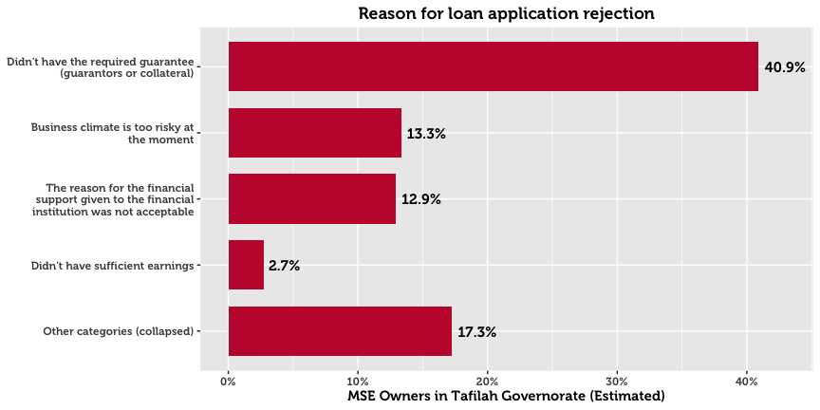

Of those who receive a loan, 46.2% receive it from a bank, and 42.0% from a micro-finance institution. Very few MSEs in Tafilah report financing from government programs such as JEDCO and IRADA (4.1%), international donors or donor-funded projects (2.0%), or private money lenders (0.6%). When asked about the primary reasons for choosing a specific institution, 47.5% cite that their institution of choice offers the best financial prospects. 14.8% cite that they chose a particular avenue because it is easy to understand and followed simple procedures. 11.6% cite that it is the best strategic option.

Men and women differ greatly in the amount of money requested in loan applications. Whereas men request a median of 4,000 JOD, women MSE owners are far more conservative at 1,000 JOD. These differences may be attributed to the fact that the sex of the business owner is strongly associated with the subsector and location of the business.

# Systems, Processes and Networks

Online and offline use of computers within MSEs is minimal, at 8.7% of firms. Smart phones and ordinary mobile phones are used by 41.9% and 48.6% of MSEs respectively.

|  |  |  |  |  |  |
| --- | --- | --- | --- | --- | --- |
| **Resource Use (Tafilah)** |  | **All** |  | **By Sex of the Owner** | |
|  |  | *N* = 2,120 |  | Men | Women |
| Mobile Phone |  | 48.6% |  | 47.6% | 57.4% |
| Smart Phone |  | 41.9% |  | 42.7% | 34.4% |
| Vehicle |  | 20.0% |  | 21.1% | 9.2% |
| Social Media (work purposes) |  | 7.1% |  | 7.6% | 2.3% |
| Computer (with internet) |  | 6.4% |  | 6.7% | 2.9% |
| Computer (without internet) |  | 5.0% |  | 5.1% | 4.5% |
| Email |  | 3.3% |  | 3.6% | 1.2% |
| Public Internet Location |  | 2.1% |  | 2.3% | 0.0% |

Only 7.1% use social media as part of business operations (14.6% for either work or personal). Naturally, this rate is more pronounced in the ICT sector, for which the digital environment is the main mode of work. The low number of social media users suggests that few MSEs understand social media, and that any target audience for social media is small. Email is even less ubiquitous, at 3.3%.

## Cooperation with Other Businesses[11]

In the previous 12 months, 83.6% of MSEs had often or always cooperated with other businesses to in some capacity. The most frequent type of horizontal linkage was cooperating to purchase inputs, services, or equipment (73.1%), followed by cooperation on market products/services (44.1%) and industry discussions (34.6%). Roughly one third worked with other businesses to transport goods to points of sale.

Other forms of cooperation were less common however, with 85.0% of MSEs rarely or never receiving certifications (such as ISO, International Accreditation, First Aid etc.), and over three quarters rarely or never receiving trainings from other businesses.

|  |  |  |
| --- | --- | --- |
| **Horizontal Linkages* (Tafilah)** |  | **All** |
|  |  | *N* = 2,120 |
| Purchase inputs, services, or equipment |  | 73.1% |
| Market products or services |  | 44.1% |
| Discuss information about the industry you are in |  | 34.6% |
| Transport goods to points of sale |  | 30.6% |
| Other |  | 23.4% |
| Receive trainings |  | 23.0% |
| Receive certifications |  | 15.0% |
| *\* captures owners who responded “often” or “always” for each form of cooperation* | | |

## Corruption

With respect to bribery, 88.3% of enterprises report that they have rarely or never been asked for an informal payment.

## 

## Financial Planning

Three out of four of businesses keep some form of financial records. However, the vast majority of businesses record their finances (74.6%), however only 1.3% record them digitally. A quarter of businesses keep no financial records whatsoever. A further indication of the lack of planning and financial organization is that only 51.8% compare their business performance against their financial goals.

## Memberships & Access to Networks

For the most part, MSEs in Tafilah are not part of associations. With the exception of the Chambers of Commerce and Industry (for which 25.3% and 18.6% of MSEs were members), no association garners more than 11.0% of MSEs in the governorate. These categories included professional or trade associations (10.9%), cooperatives (6.5%), youth groups (3.4%), women’s groups (3.1%), informal savings or loan groups (2.7%), ward or village committees (2.5%), microfinance groups (1.9%), and NGOs (1.9%).

Despite the fact that few participate in formal networks, 78.8% believe they can get a meeting with the mayor, the highest proportion maintained by any governorate. This is lower for woman-owned businesses (54.4%).

|  |  |  |  |  |  |
| --- | --- | --- | --- | --- | --- |
| **Memberships (Tafilah)** |  | **All** |  | **By Sex of the Owner** | |
|  |  | *N* = 5,513 |  | Men | Women |
| Chamber of Commerce |  | 25.3% |  | 26.9% | 10.7% |
| Chamber of Industry |  | 18.6% |  | 19.8% | 8.4% |
| Formal trade, business, or professional association |  | 10.9% |  | 11.0% | 10.7% |
| Cooperative |  | 6.5% |  | 6.8% | 4.3% |
| Youth group |  | 3.4% |  | 3.7% | 0.0% |
| Women’s group |  | 3.1% |  | 2.5% | 8.2% |
| Informal savings or loan group |  | 2.7% |  | 2.9% | 1.0% |
| Ward or village committee |  | 2.5% |  | 2.5% | 2.2% |
| Microfinance group |  | 1.9% |  | 2.0% | 1.0% |
| NGO |  | 1.9% |  | 2.1% | 0.0% |

# Policy and Regulations

82.4% of MSE owners in Tafilah believe they know about the laws and regulations that govern their firm. As ‘digital literacy’ is relatively low, two thirds resort to traditional source of information. In particular, MSE owners go to their municipality, friends and family, or lawyer for information. Only 5.4% resort to government websites.

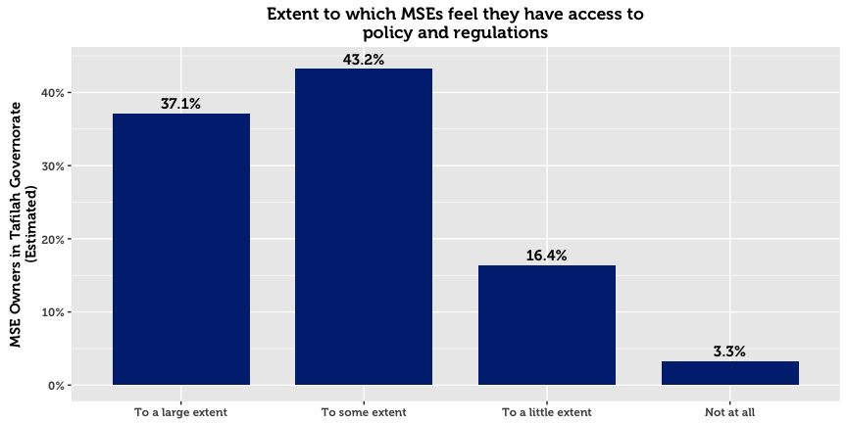

|  |  |  |  |  |  |
| --- | --- | --- | --- | --- | --- |
| **Policy Sources (Tafilah)** |  | **All** |  | **By Sex of Owner** | |
|  |  | *N* = 2,120 |  | Men | Women |
| Local municipality |  | 35.4% |  | 36.9% | 21.9% |
| Family and friends |  | 30.9% |  | 29.7% | 42.4% |
| Lawyer |  | 12.6% |  | 13.6% | 3.2% |
| No use for this information |  | 5.6% |  | 4.6% | 14.5% |
| Government website |  | 5.4% |  | 5.9% | 1.0% |
| Other |  | 5.0% |  | 4.8% | 6.6% |
| Do not know |  | 2.9% |  | 2.2% | 9.4% |
| Local businesses and enterprises |  | 1.1% |  | 1.3% | 0.0% |
| Business support center |  | 0.8% |  | 0.7% | 1.0% |
| Refused to answer |  | 0.2% |  | 0.3% | 0.0% |

1. In this paper, micro- and small-enterprises are categorized in accordance with USAID LENS’ definition. A business (formal or otherwise) having fewer than 10 full-time employees (excluding the owner) is classified as a microenterprise, whereas businesses with 10 to 49 full-time employees, are categorized as small.
2. Throughout this paper, the area of “Amman” refers to the geographic area of Amman governorate, excluding the Greater Amman Municipality (“GAM”) which was excluded from the study. The area of “Aqaba” refers to the Aqaba Governorate, excluding the Aqaba Special Economic Zone (“ASEZA”).
3. Although results are representative of MSEs within each geographic area, results cannot be disaggregated on a more granular geographic level without compromising on acceptable sampling error rates. This is due to the clustering design in the first phase.
4. This total represents an estimate for the total number of MSE owners, without accounting for multiple-ownership. The survey reveals that 35.5% of business owners in Tafilah have a second business. The total number of MSEs is therefore higher than the total number of MSE owners. Throughout this report, we relax this strict distinction and commonly use language such as “X% of MSEs…” when referring to data about MSE owners.
5. In this report, “Population Estimate” means the absolute number of MSE owners in Tafilah, estimated using inclusion probabilities from the random sample. This statistical definition of “population” is not the same as the general understanding of the word in everyday language, which refers to the total number of people living within the boundaries of a nation state. Although many statistical publications use or when referring to these estimates, in this report we use the more intuitive notation *N* to denote population estimates, and *n* to denote unweighted sample counts.
6. Four sectors are examined throughout this report: Tourism, ICT, Transport, and Food Processing. These groupings are created on the basis ISIC-4 classifications collected in the survey, and are the primary data to reflect the four target sectors used for interventions in the LENS project.
7. Due to the large number of ISIC categories and the relative infrequency of most of them in the observed data, the search procedure for finding sectors of interest is conducted through statistical learning techniques, validated through resampling. This allows for most spurious relationships to be rejected.
8. In this report, a home-based business is any enterprise or income-generating project that operates from the owner’s home. As a result, this definition does not include MSEs operating in the homes of clients (maids, personal care, etc.)
9. Due to an error in the tablet software used for interviews, questions concerning technical assistance were only posed to MSE owners with employees.
10. Understood as financial or resource contributions from an international or local agency
11. Questions on cooperation with other businesses were only asked to SME owners in Aqaba, Karak, and Tafilah.